CO-1 ASSESSMENT TOOL -OUTPUT PREDICTION
COUSE CODE: CSA0307 NAME: M. BALAJI
COUSE NAME : DATA STRUCTURES REG NO: 192525059
DATE : 24/07/2026
QUESTION-1-LARGEST AND SMALLEST ELEMENT
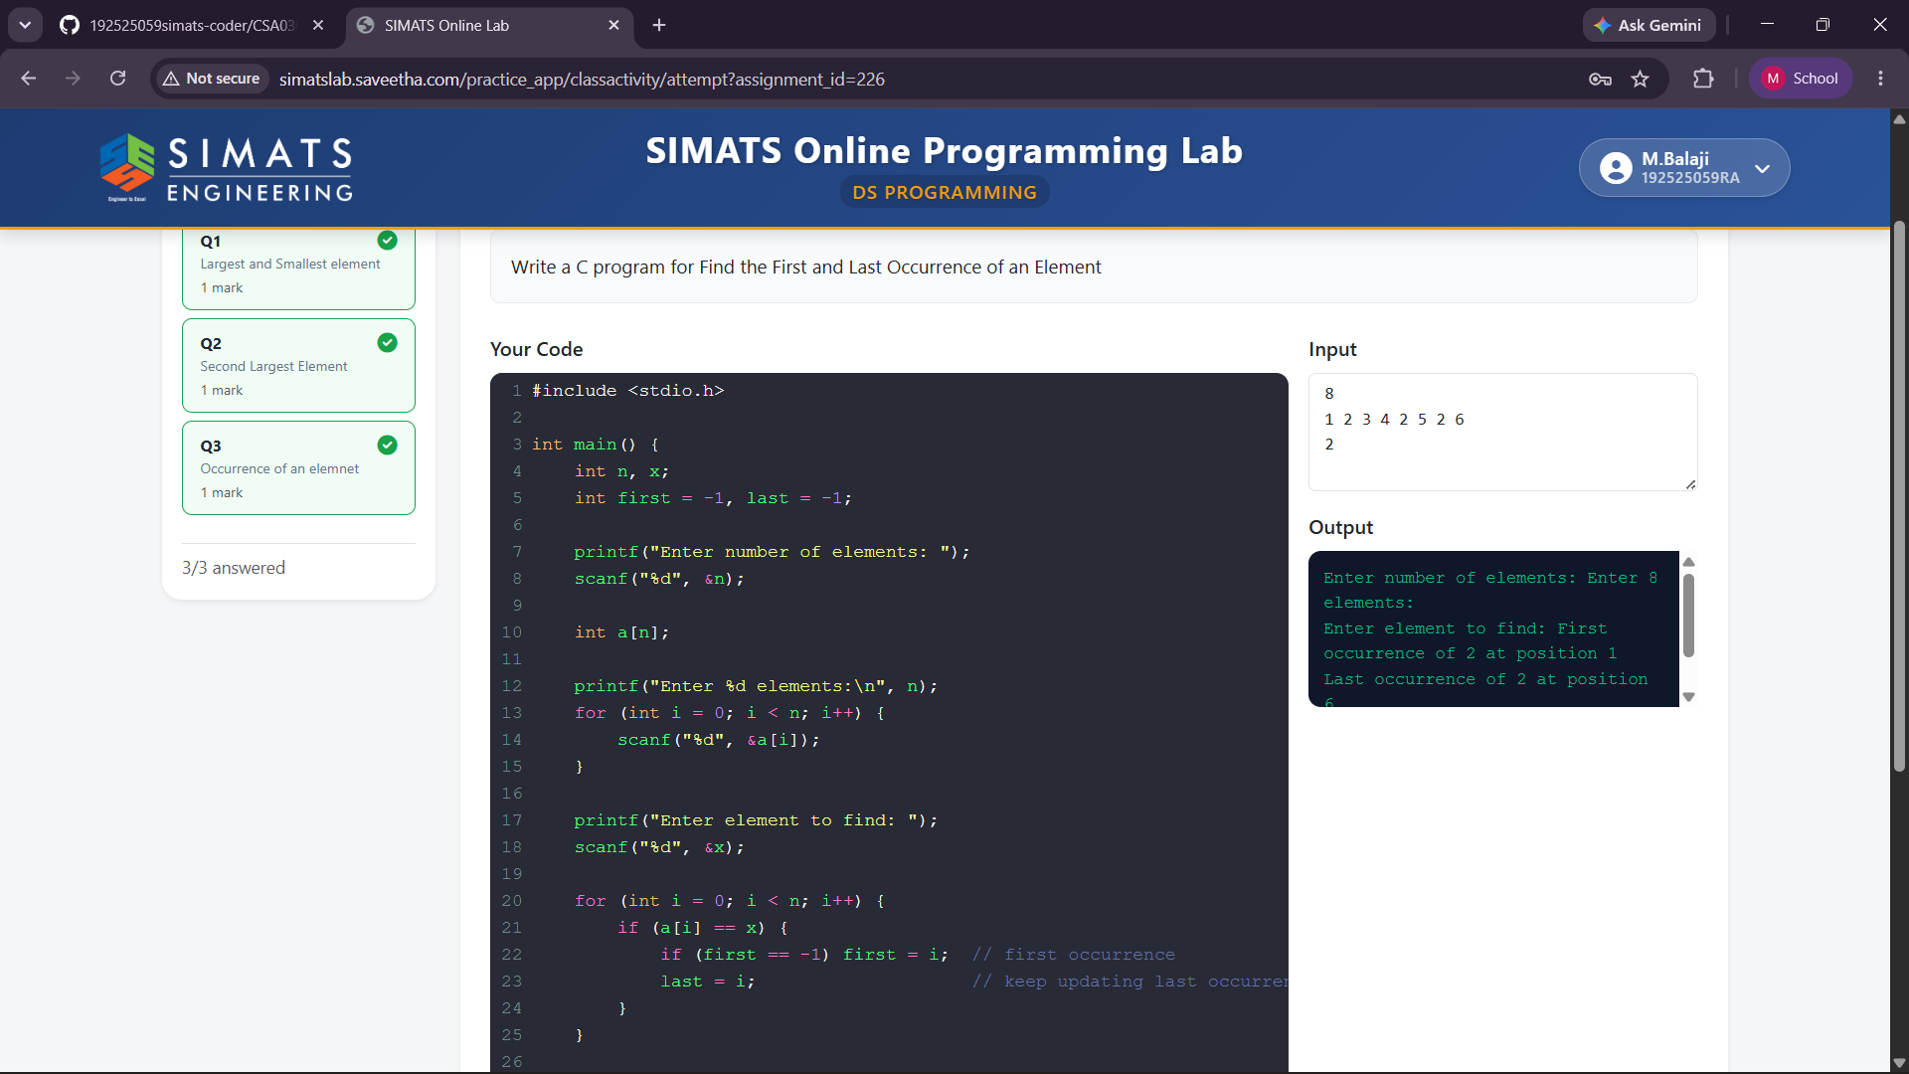
QUESTION -2 SECOND LARGEST ELEMENT
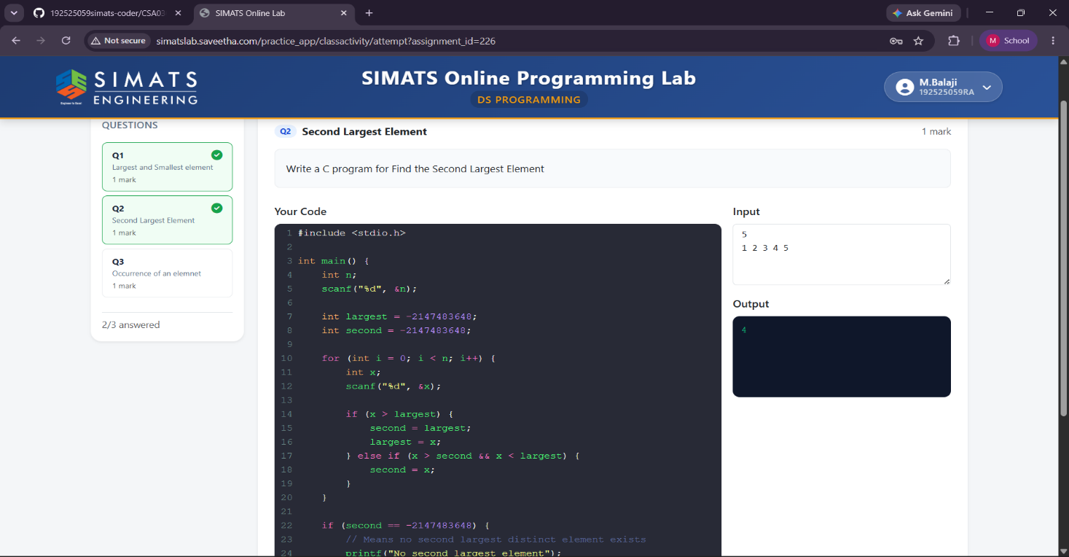

QUESTION -3-FIND LAST OCCURRENCE OF AN ELEMENT
